**Step 1 :** **Login to Jenkins server and click on configure under your webapp project**

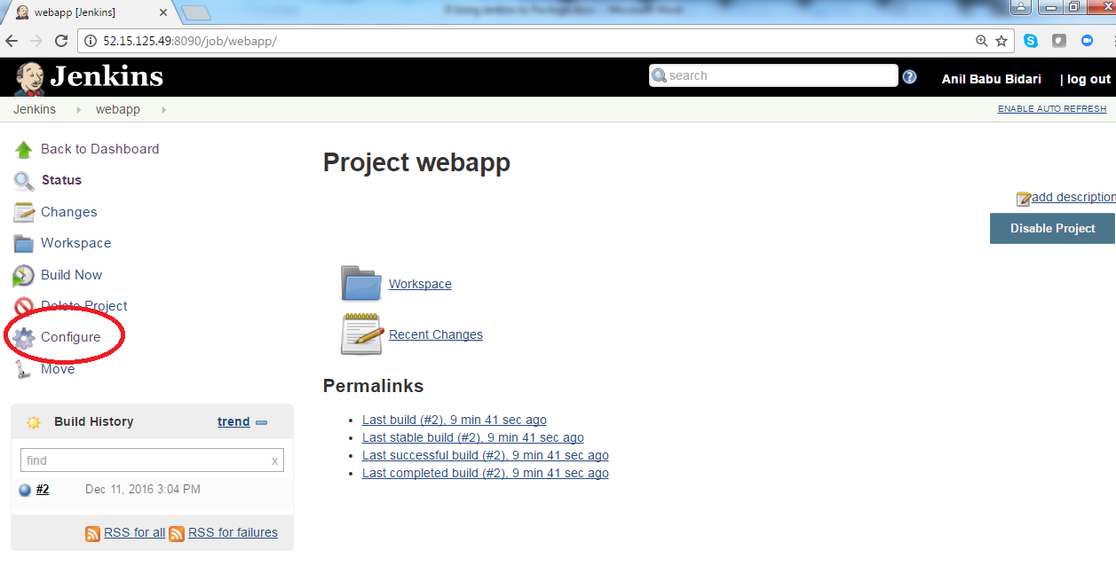

**Step 2 :** **click on Build**

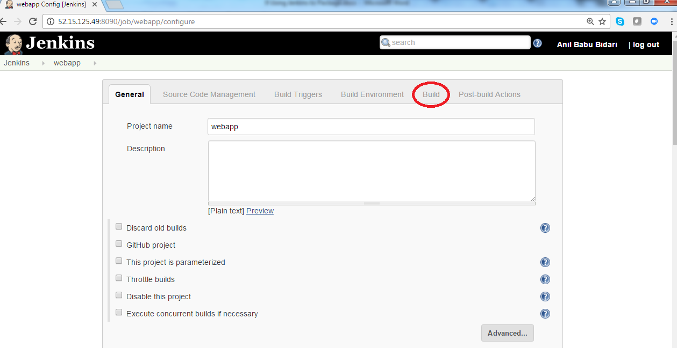

**Step 3 :** **click on Advanced**

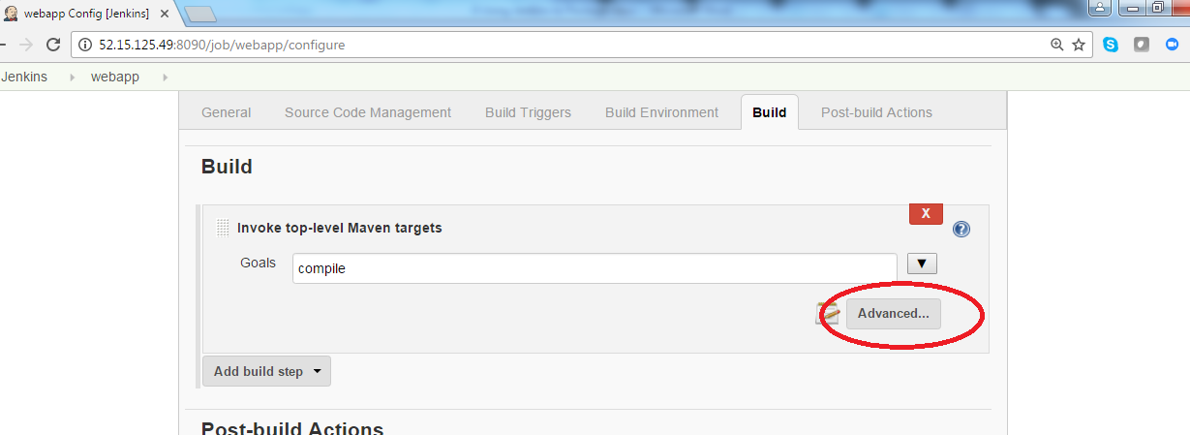

**Step 4 :** **Change value to “ clean install -DskipTests package”**

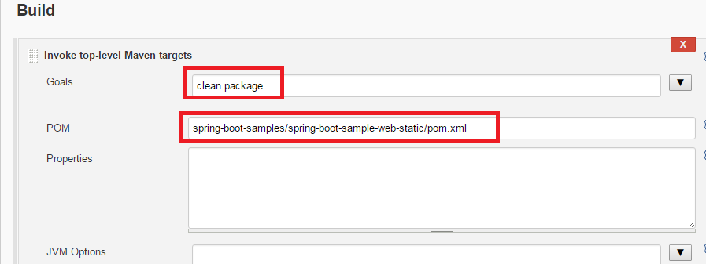

**Step 5 :** **Click on Build now**

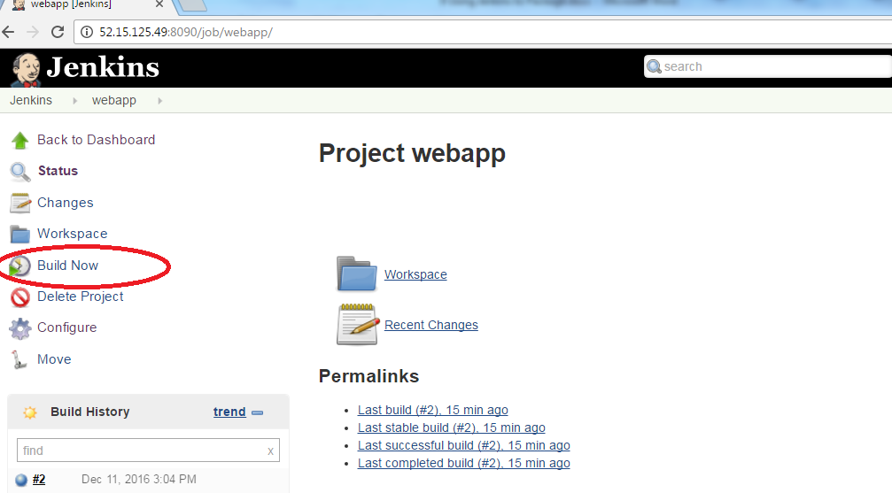

**Step 6 :**  **click on build history #3 based on your build**

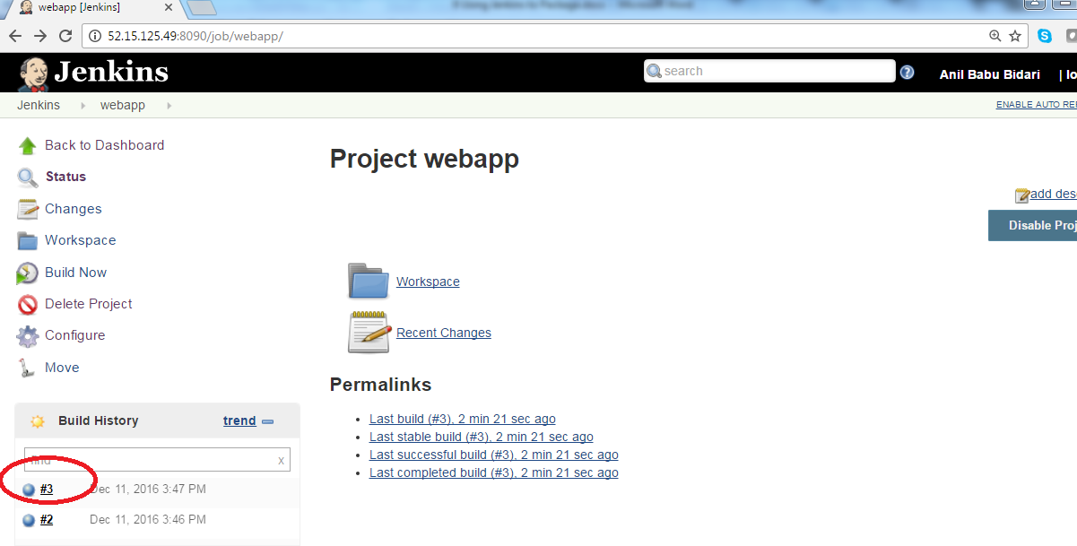

**Step 8 :**  **click on console output**

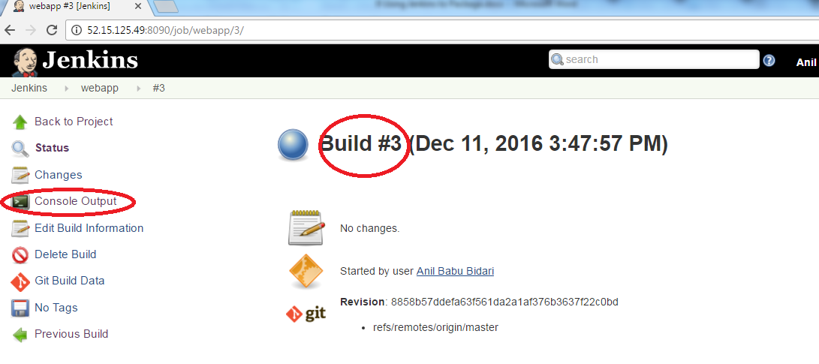

**Step 9 :**  **observe the location of your code and maven compile gets executed**

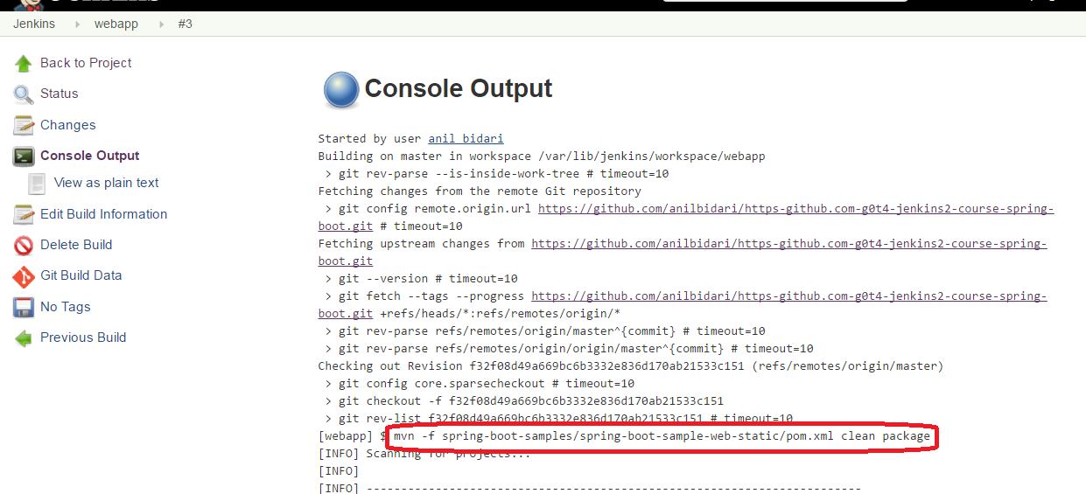

**Step 10 :**  **ssh to your machine and observe the output**

cd /var/lib/jenkins/workspace/webapp/spring-boot-samples/spring-boot-sample-web-ui/target

ls -l

